World War l by Éabha
The First World War began on July 28th 1914. Europe had split into two families of countries. The Allies were the British Empire, France, Belgium, Russia and later on America in one family. The Central Powers were on the other side and they were Russia, Germany, Austria, Turkey and Bulgaria.

Many people believed it would not last long because Britain was so powerful but it lasted for 4 long years.

Soldiers in the trenches would spend their days doing chores, firing at the enemy, playing cards and writing letters home. Incredibly nine out of ten men survived.

By the winter of 1915, the opposing sides had both dug long ditches called trenches which faced each other, in some places just 30m apart! These lines of narrow trenches stretched from the Belgian coast to Switzerland, and were known as the Western Front. Over five million British soldiers spent time living in these muddy, miserable ditches, taking it in turns to be on the Front Line – the trench closest to the enemy.
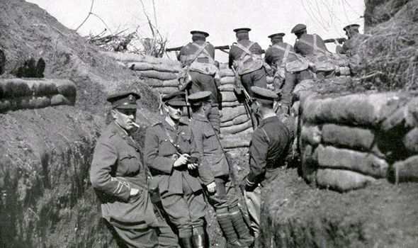

For the first time, powerful new weapons and vehicles were used, at sea, on land and in the air.75% of all men
who died in World War 1 were killed by artillery.

The largest battle of the World War 1 - the battle of the Somme – is one of the bloodiest battles in history.
It was fought by the French and the British against the Germans on both sides of the River Somme in France, and lasted for more than five months. Over a million men were killed or wounded, and it was the first time a tank was used in combat.

Both on the battlefield and back at home, some incredible creatures helped to transport soldiers and goods and saved lives.

Almost a million horses were involved in the war. Soldiers on horseback were known as the ‘Cavalry’ and horses also pulled some of the gigantic guns, ambulances and supply wagons.
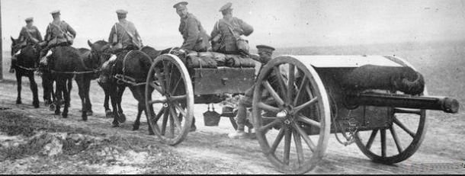

Gas from horse droppings could even be used to power lamps.

British families gave their pet dogs to the army so they could carry messages in special tubes on their collars.
Dogs were very fast, difficult to shoot at and they also caught rats.
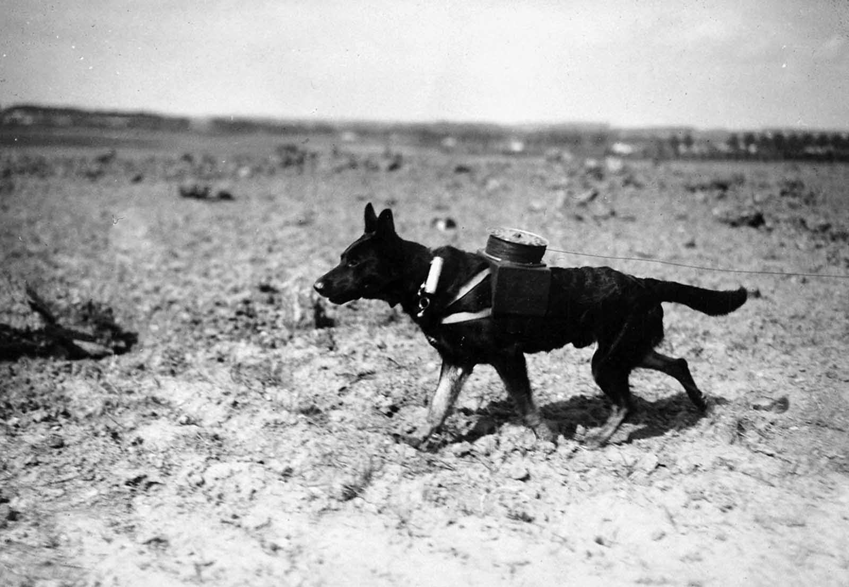
Pet pigeons were drafted in to carry messages over long distances, often carrying news from the front line back to Britain. Germans trained hawks to kill any carrier pigeons they saw. 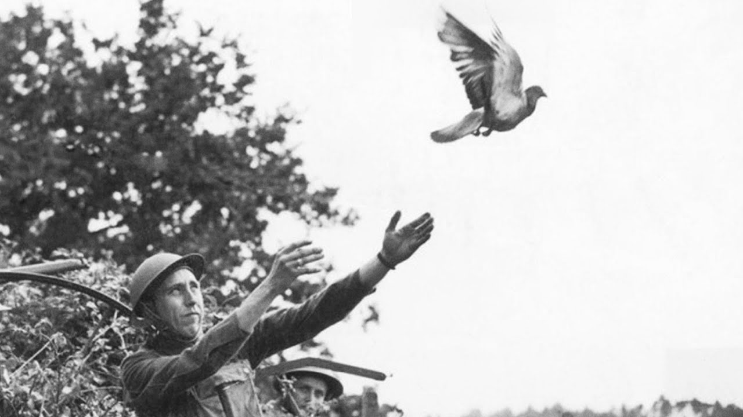

Goldfish did their part too – after gas attacks the gas masks were rinsed. If the rinsing water killed a goldfish that was placed in it that meant that the masks still had poison in them.

Before the war, a women’s place was in the home but with the men away at war, millions of women stepped up to the plate and went to work in factories, farms, offices and shops. Without them the war would not have been won.

WW1 ended on the 11th hour of the 11th day of the 11th month in 1918. An agreement was signed by Germany and the allies. This day is called Armistice Day and people still wear poppies on the date to commemorate the war and those who fought and died in it.
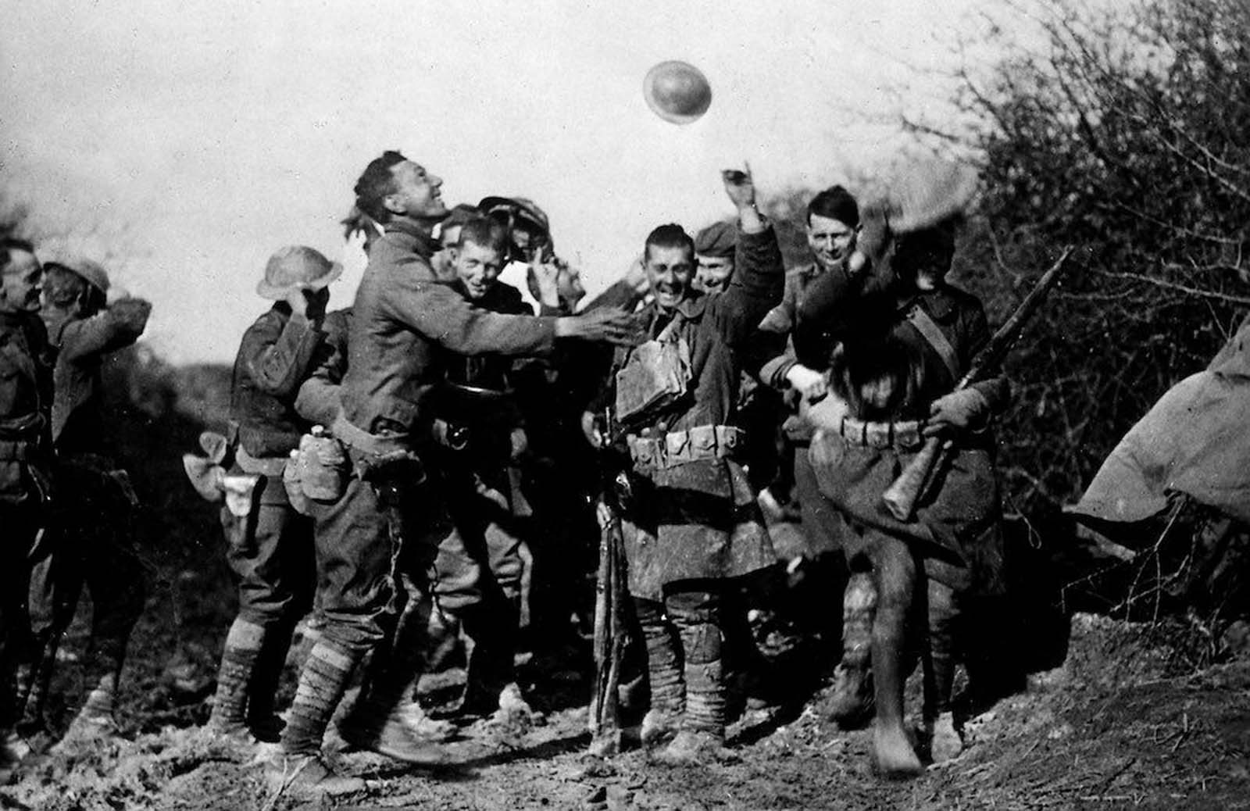

The End

